Background Research of Diamond Buying:

<https://www.americangemsociety.org/en/4cs>

<http://www.zales.com/wedding/education/diamond-buying-guide/category.jsp?categoryId=3334564>

<http://www.bluenile.com/education/diamonds>

<http://4cs.gia.edu/EN-US/the-diamond-4-cs.htm>

* Standardized system of measuring diamonds
* Color
* Cut
* Clarity
* Carat weight
* Universal method for assessing quality of a diamond
* Universal language so that customers know what they are buying
* Color
  + Based on the absence of color
  + Scale measures the diamonds from D-Z or colorless to yellow
  + Many colors are subtle and unnoticeable to the untrained eye
* Clarity
  + Diamonds are natural carbon exposed to tremendous heat and pressure
  + Inclusions-little specs “blemishes”
  + Size, number, relief, nature, and position that affect appearance
* Cut
  + Symmetry
  + Most important C
  + Brightness
* Carat weight
  + Metric carat is defined as 200 milligrams
  + Each carat subdivided into 100 ‘points’
  + Basically the size of a diamond
* Cut is the most important
* Diamonds have a large range in different prices
* Diamonds come in many different shapes and sizes

<https://www.baunat.com/en/inspirational-diamond-blogs-on-how-to-buy-a-diamond>

How to buy a diamond blog

<http://www.lumeradiamonds.com/diamond-education/diamond-shape>

diamond shapes and more info about them

Mind Map



Text/Images for the Web Page:

Cut - A diamond’s fire and sparkle that give it life are maximized with great cut allowing light to refract from one facet to another then dispersed back through the top of the diamond in a burst of color and brightness. When poorly cut, precious light escapes through the bottom facets. There are millions of cutting combinations that will maximize the beauty of countless types of rough diamond crystals. And millions more will ruin the diamond’s potential beauty in an attempt to make the diamond weigh more so that it can be sold as a “bigger” diamond (weighing more, but visually not as big). Comparing two diamonds with the same carat weight, the artistically cut diamond will have BOTH superior beauty and larger visual size than the standard cut diamond which was cut just to weigh more for advertising purposes.

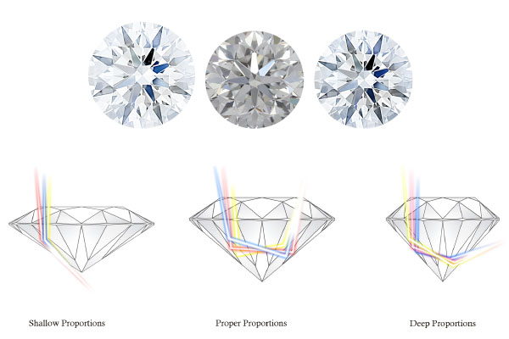

Clarity - Clarity is an indication of a diamond's purity. When a rough stone is extracted deep beneath the earth, tiny traces of natural elements are almost always trapped inside. These “inclusions”, are sometimes referred to as “birthmarks” because they are formed naturally and are unique to each diamond. Skilled diamond artisans (diamantaires) painstakingly examine each rough stone to determine how to cut it in order to eliminate or reduce inclusions and flaws. Their goal is to craft a diamond of the highest clarity possible. The fewer, smaller, and less noticeable the inclusions, the more rare and higher the price of the diamond.

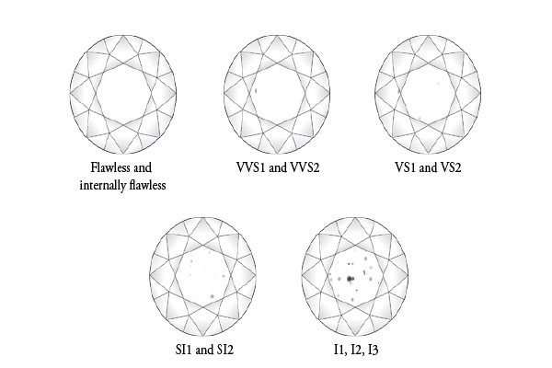

Color - Color is the natural body color visible in a diamond, and is determined completely by nature ranging from colorless to yellow. Basically, the less color, the more rare and higher the price (except for natural fancy colors, like pink or intense yellow diamonds) Color is expressed in a single letter. The highest diamond color available on the market is “D”; the diamond color you choose is what you personally prefer.

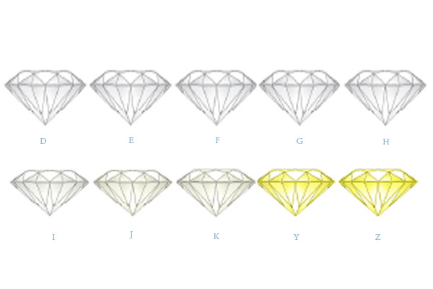

Carat Weight - The weight of a diamond is expressed in carats. In most cases when holding other factors constant, the higher the carat weight category, the greater the per-carat price of the diamond. A carat is a unit of weight equaling 1/5 of a gram. Diamond weight is subdivided further into smaller units commonly referred to as points. A point is equal to .01 carat. A one carat diamond is made up of 100 points.

